**Software System Design**

**Document Specification**

Sport Franchise

Joseph DeMario, Joseph Tooker, and Frank Palaia

**Table of Contents**

Introduction....................................................................................................................................................3

Application Architecture................................................................................................................................3

System Functions...........................................................................................................................................3

User Interface.................................................................................................................................................5

Components ..................................................................................................................................................7

Database.........................................................................................................................................................9

Required Hardware and Software .................................................................................................................9

**Table of Figures**

Figure 1. Use Case Diagram..........................................................................................................................5

Figure 2. Form 1.............................................................................................................................................6

Figure 3. Web Application Picture 1 .............................................................................................................6

Figure 4. Web Application Picture 2 .............................................................................................................7

**1. Introduction**

Utilizing Microsoft Visual Studio IDE incorporates class libraries into web applications, where the DLL component fetches data from our Microsoft Access database. The class library will define the function to be performed by the system and will be referenced in the web application as an outside third party source, created separately from the system itself. The object data source created by the class library will be displayed via the ASP.NET framework gridview design. To fulfill business objectives, the system will also handle additional functions to add to list objects as the organization wishes to build a roster for the team. Dynamic paging will ensure organization to keep track of finances to ensure affordability and structure of the team.

Teams, players, managers and agents are able to easily view a web based application that displays the appropriate information pulled from our sports franchise database. From this application, managers can organize and set up meetings with agents, add players to a team after meeting with said player, agents can view their assigned players and vice versa, and teams can pay players the appropriate amount of money based on their payroll.

**2. Application Architecture**

The anticipated architecture system of our project is one that is multi-layered. We believe this architecture model best fits our sports franchise project as it is the required model needed to complete this project. In other words, a multilayered architecture model is a client server application in which visual display, application processing and data management are separated. In our case, the visual display is the web application that appears when running our code. The application processing is the chunk of the project that makes the functionality possible, or the code needed to connect the database and the functions needed to add components to the web application. The data management is the sports franchise database and how that database changes over the course of the project.

**3. Required System Functions**

***System Requirements***

● Available personnel are referenced from Access database

● Implementation of reservation system

● Implementation of shopping cart system

● Management of payroll

● Must include one business object (DLL component)

● Must include one web service component that allows end users to interact with the system for certain business functions

**Functional Requirements:**

● Only managers can schedule meeting with agents

● Can only meet agents upon approval

● Can only hire personnel if salary is within remaining/available payroll

● Can only hire personnel if they are available

● Can only hire/pay personnel once

**Un-functional Requirements:**

● Each personnel has their own agent

● Personnel, agents, amd department have unique IDs ,

● Agents may represent one or more personnel

● Should hire at least one coach to be considered team

● Managers can renegotiate personnel salaries

**4. User Interface**

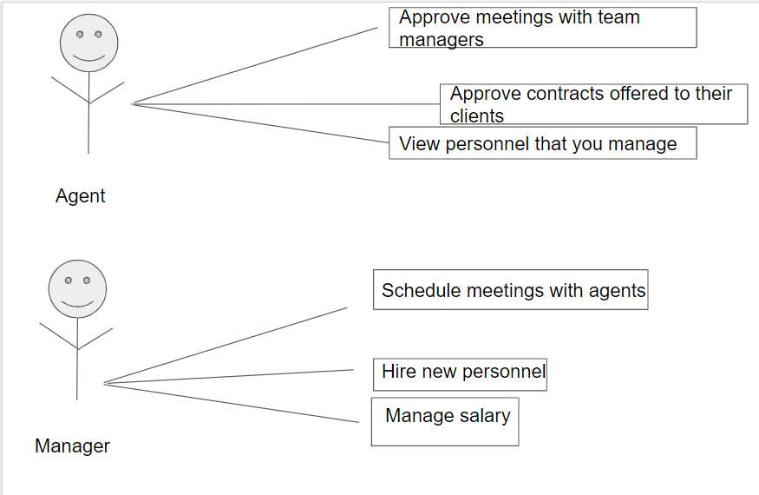

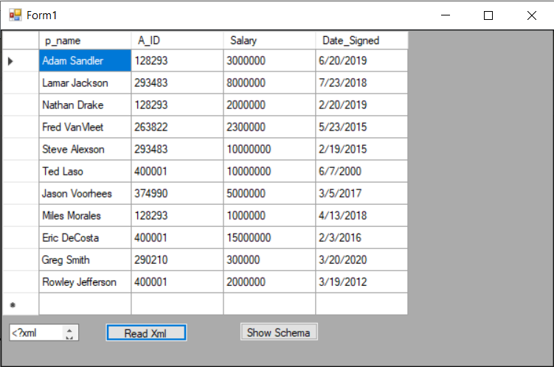

Sample web form to view personnel before web page implementation.

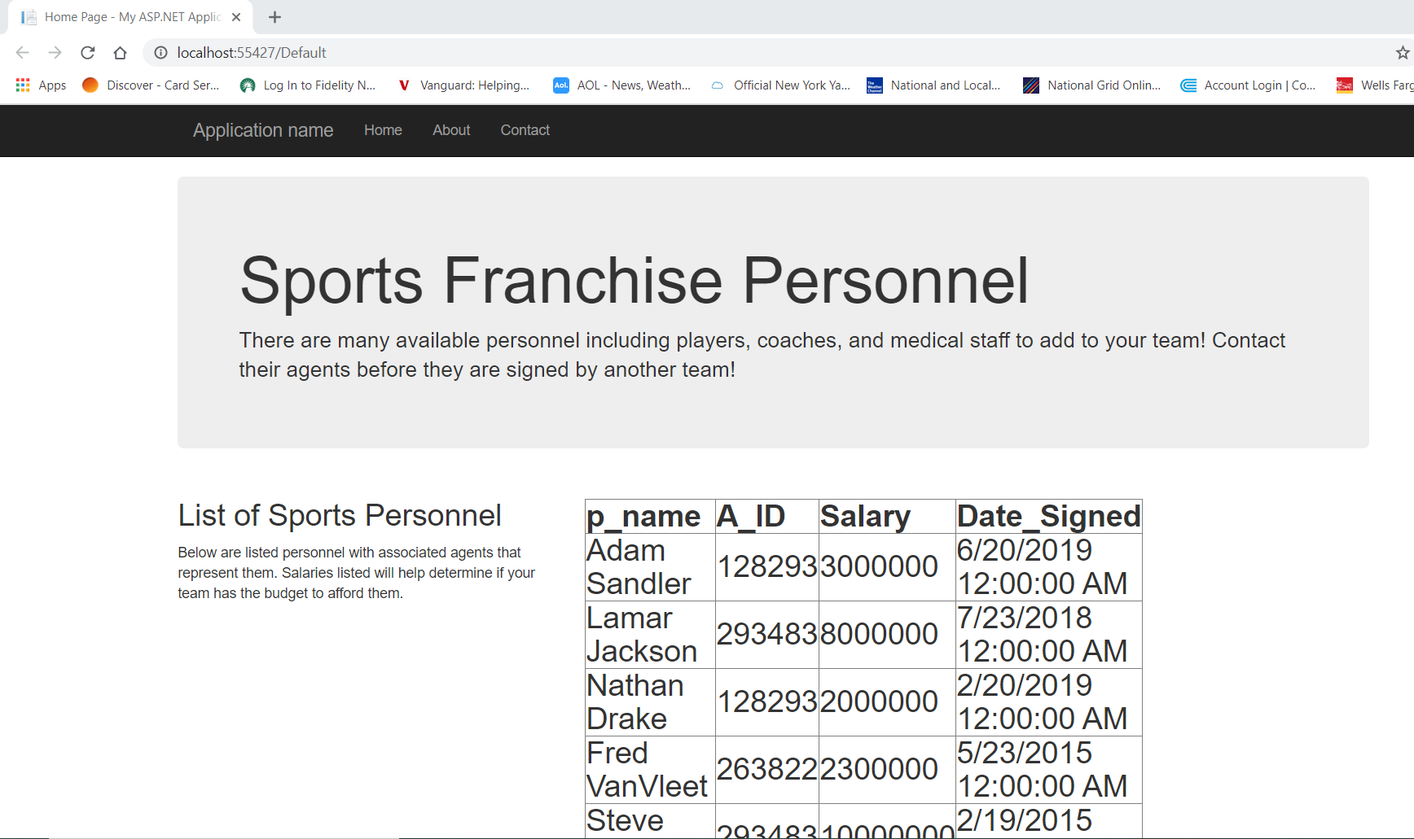

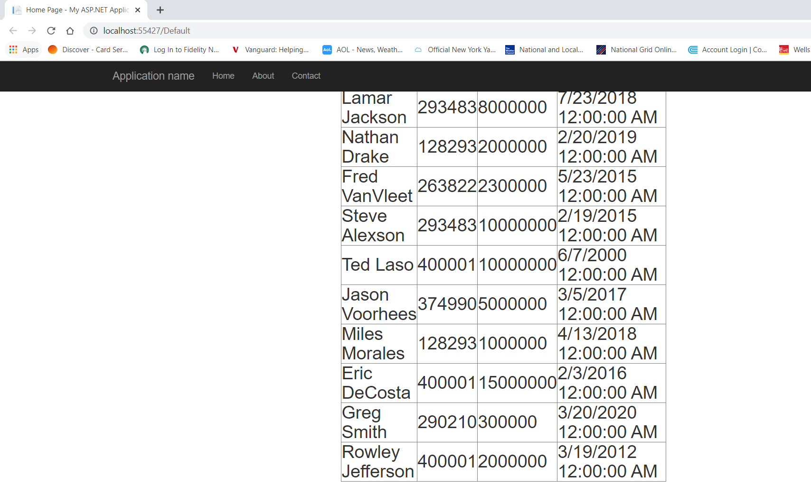

Webpage that displays personnel on webpage.

**5. System Components**

List of system components or modules, their functions and how they interact with each other.

|  |  |  |  |  |
| --- | --- | --- | --- | --- |
| Name | Function Description | Input Data | Output Data | Dependencies |
| CSC430Lab4.accdb | Reference source of database | SQL create statements and queries | Tables | Microsoft Access |
| SportsClassLibrary1 | DLL middle layer component where data link is established | CSC430Lab4.accdb | No executable file was created  DLL | CSC430Lab4.accdb |
| SportsWebApplication1 | Web application that displays table from access database | SportsClassLibrary DLL file | Web page displaying database information | ASP.NET Framework to display contents visually to user  DLL file required to make data link |
| scheduleMeeting() | Void type function where spot is reserved on list to meet with agent | Date, time | Queue with associated agent along with reserved time slot | Agent must agree  Time slot must be available/open i.e. room on queue |
| addPersonnel() | Void type function where personnel i.e. player or coach or medical staff, is added to team | Object class of personnel | List with added members | Personnel must not be previously added  Remaining payroll must afford salary of personnel  Must have had previous meeting with associated agent |
| managePayroll() | Void function that helps determine affordability of personnel to be added. Will deduct funds based on salary and also indicate whether the transaction is complete | Salary variable of class | Remaining float/double variable of payroll after transaction | Total net of payroll must be within range of salary. Once payroll doesn’t meet amount on salary or is zero balance, user can not make any more transactions |
| viewPersonnel() | Void function that views personnel on team, get method | Button handler | List of personnel | List must contain at least one member.  After transaction goes through, member will be viewable on team  Personnel table from access database |
| viewAgents() | Void function that views agents to be contacted, get method | Button handler | List of agents | Agents table from access database |
| getPersonnel() | Void function that views personnel that have yet to be added on team, get method | Button handler | List of available personnel not yet added on team | Personnel table from access database |
| removePersonnel() | Void function that removes personnel from team | Button handler | Updated list of personnel  Updated payroll | Personnel table from access database  Must be at least one member on team to remove |

6. Database

**6. Database**

Agent(**A_ID**, Agent_Name)

Department(**D_ID**, Department_Name, Number_Of_People)

Personnel(**P_ID**, Personnel_Name, D_ID, A_ID, Salary, Date_Signed)

Team(**T_ID**, Team_Name, Location, Payroll)

AvailablePersonnel(**P_ID**, Personnel_Name, D_ID, A_ID)

**7. Required Software and Hardware**

A web browser such as Google Chrome is required to access the webpage.